3CD Mathematics Specialist First Semester May 2010
Examination Revision Material

Complex Numbers

1. [11 marks]

Given that z and w⁻¹ are complex numbers such that :

zw⁻¹ = 0.4 – 0.7i
 = 4 - 2i

Determine :

a. w
[1]

b. z

[2]

c. z⁻¹

[2]

Another complex number v is given by v = r cis θ. Write expressions, in terms of r and θ, for the following complex numbers :

d. v² in polar form

[2]

e. -2v in polar form

[2]

f. v + 2 in Cartesian form i.e. a + bi

[2]
5. [11 marks]

Sketch on the following Argand diagrams, the locus for :

a. | z - 5 + 2i | ≤ | z + 3 – 2i |

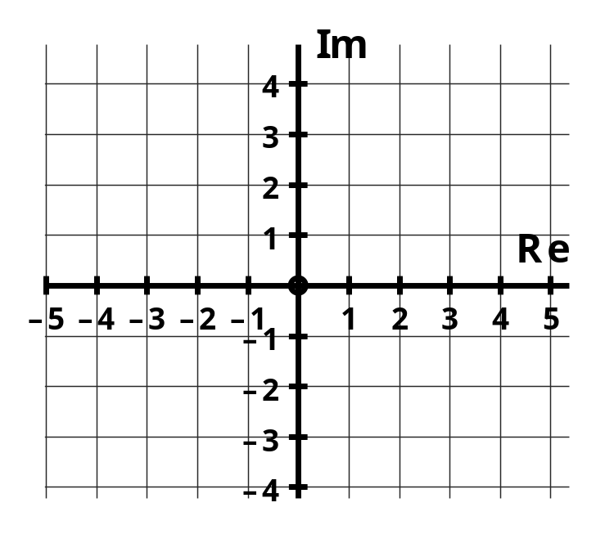

[2]

b. Arg(z – i) = 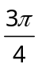 and -4 < Re(z) < 1
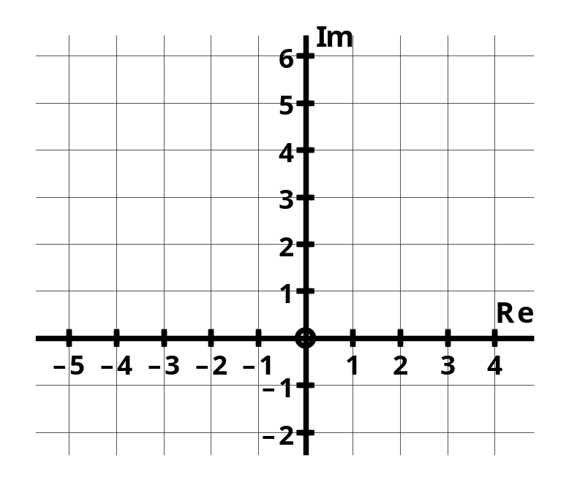

[3]

5. [11 marks]

The locus for | z + 3 – 4i | = 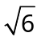 is shown in the Argand diagram below.

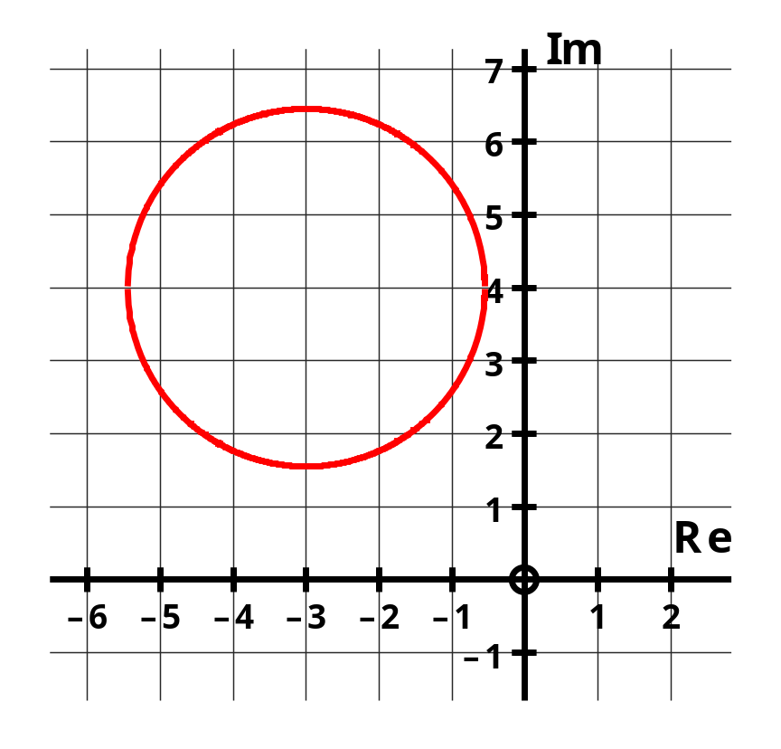

c. Give the minimum value for |z|.

[2]

d. Give the maximum value for Arg(z), correct to 0.01 radians.

[4]

15. [6 marks]

b. i. Express cis 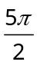 in exact Cartesian form.

[1]

ii. Given that cis 3θ = cis 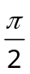 , determine the 3 possible exact values for
cis θ, in Cartesian form.

[Hint : consider an Argand diagram]

[5]

  - The Argand diagram below shows z₁ as representative of ANY complex number, with
z₂ = cis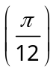 :

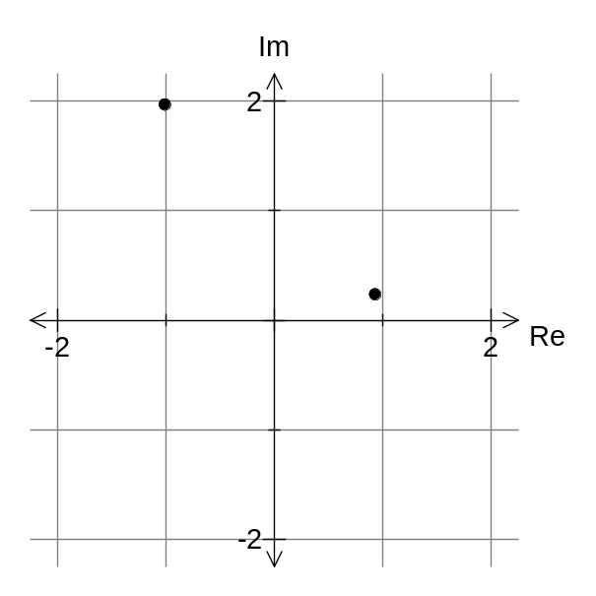

z₁

z₂

- Show the position for the complex number z₃ = z₁(z₂)² on the Argand diagram above.

[2]

b. Simplify the expression z₁(z₂)¹² .

[2]

c. Solve for the value(s) of n, in the complex equation (z₂)^{n} = - i , where n is a positive integer.

[3]

20. [3 marks]

The point W on the Argand diagram below represents the complex number w where 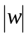 = 2.

Mark on the Argand diagram the following complex numbers clearly labelling each point.

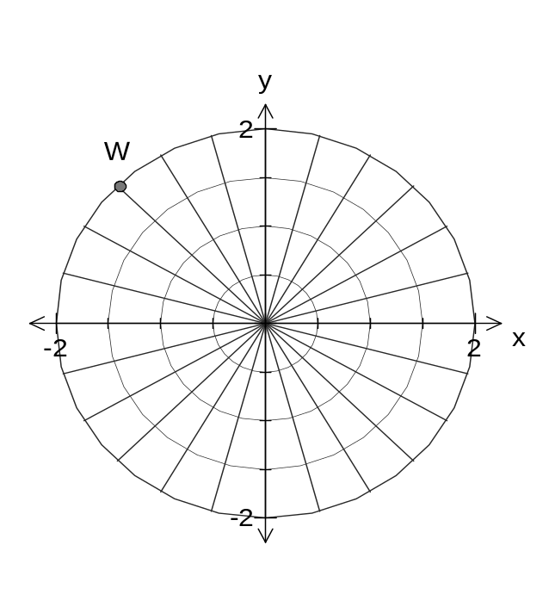
- 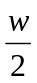

b) 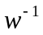

c) 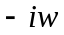

Functions

3. [12 marks]

Find 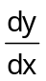 given :

a. y = 2 cos³(4x)

[3]

b. xy² + 4y = sin 2x

[4]

c. y = 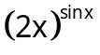

[5]

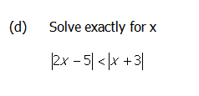

6. [8 marks]

Solve the following equations exactly :

a. | 2x + 2 | = x² - 2

[4]

b. 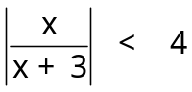

[4]

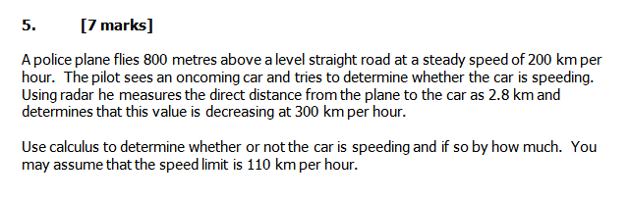

13. [9 marks]

The well known ‘ABC logo’ is parametrically defined by the equations : x = cos t
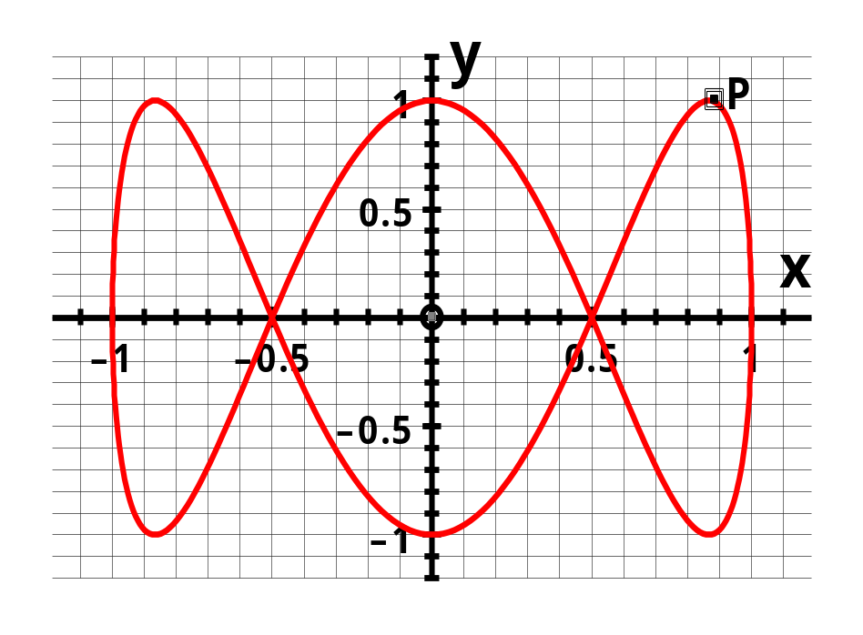
y = sin 3t

a. Find an expression for .

[3]

b. Find the slope of one of the tangents to the curve at the point (0.5, 0).

[3]

c. At point P shown above, the tangent to the curve is horizontal.
Determine the exact x co-ordinate for point P.

[3]

14. [9 marks]

The graph of f(x) = x³ ln x is shown below where x > 0.
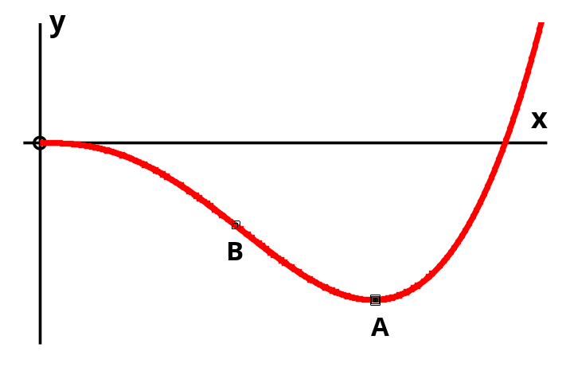

a. Determine the exact global minimum value for function f .
[Do NOT attempt to justify that a minimum is obtained]

[5]

b. Give the exact x co-ordinate for point B, the point of inflection.

[4]

5. The equation of a curve is x² + 4xy + y² = 25. Find the values of 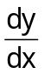 and 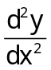 at the point where the curve meets the positive x axis.

6. If y = 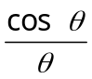 then show that :
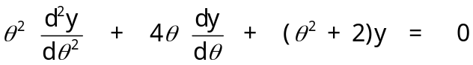

7. [6+5=11 marks]

a) Find the exact value(s) of k for which 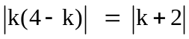

7. [6+5=11 marks]

b) The inequality 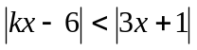 has a solution 0.625 < x < 3.5. Find the value(s) of k.

8. [2+3=5 marks]

The function f, defined for all real x by 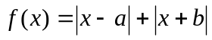, where a and b are positive integers, has the following graph.

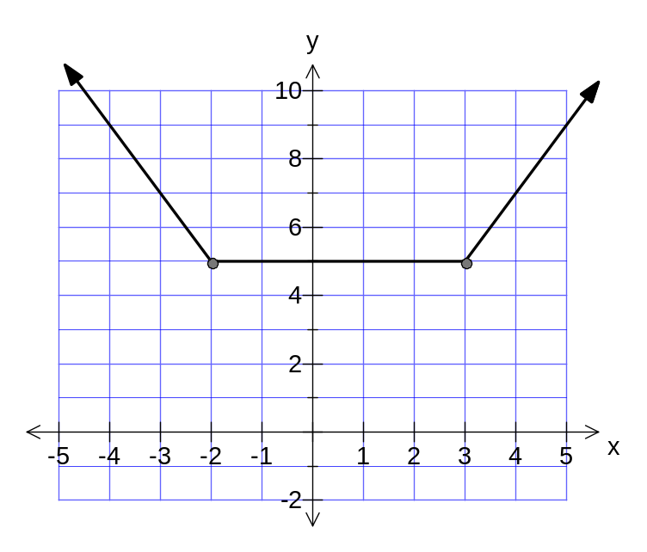

- Find the values of a and b.

b) Express as a piecewise function.

10. [7 marks]

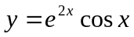 is a solution of the differential equation

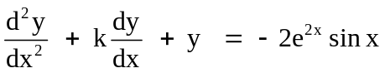 where 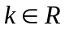. Find the value of k.

14. [2+3+4=9 marks]

Find for the following, simplifying your answer.

a) 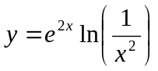

b) 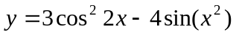

c) 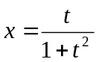 and 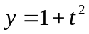
27. [8+2=10 marks]

A truck is moving towards a flood light tower at a constant speed of 7.5 m/s. The truck has an aerial attached to it which can be raised and lowered. The light from the tower causes the aerial to cast a shadow on the ground behind the truck. Not including the aerial, the truck is 3.2 m in height and 4.5 m long. The flood light tower is 29.25 m tall.

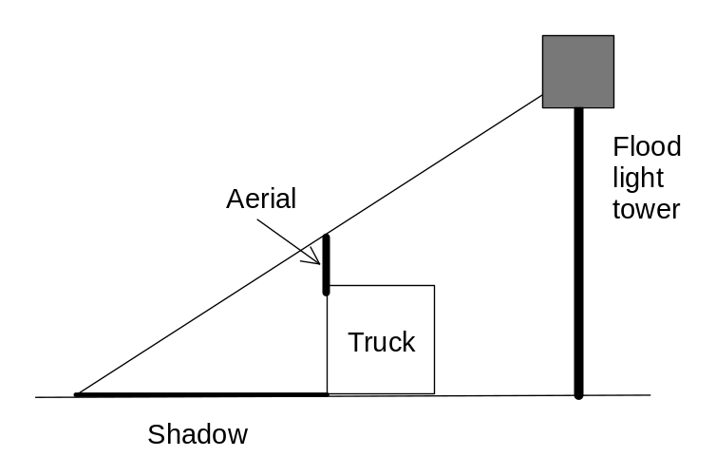
When the front of the truck is 20 m from the base of the tower, the length of the shadow is decreasing at the rate of 2.5 m/s and the aerial is 4 metres tall.

- Determine the rate of change of the length of the aerial at this instant.

27. [8+2=10 marks]

a) Determine the rate of change of the length of the aerial at this instant.

- Is the aerial being raised or lowered at this instant? Justify your answer.

3D Vectors

2. [2 + 2 + 4 + 3 + 3 + 3 + 4 = 21 marks]

Consider the following vectors in space :

a = -2i + j - 4k
b = xi + 3j - 2k
c = 5i + 2j - zk
d = 3i - 7k

Determine :

(a) 4a - d

(b) vector e such that e is parallel to d and double its length.

(c) the acute angle between vectors a and d (to nearest degree).

(d) the value of z such that c is perpendicular to a.

(e) the value of x such that a is parallel to b.

(f) a unit vector v in the direction of a.

Suppose that points A and D are determined by their position vectors a and d respectively.

(g) Determine the position vector p for the point P in space such that P divides  internally in the ratio 2:1.

5. [6 marks]

Two jets, A and B, have velocities of 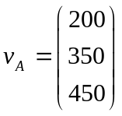 m/s and 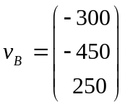 m/s.

Their positions at t = 0 are 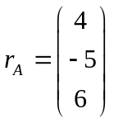 km and 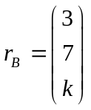 km.

It is known that the two jets are closest to each other after approximately 8 seconds.
Determine the value of k .

1. [9 marks]

If u = < –2, 3, 1 > and v = < 3, 1, –5 > determine

(a) (u + v) • (u – v)

[2]

(b) a vector which is perpendicular to both u and v.

[4]

(c) the angle between u and the x-y plane.

[3]

2. [5 marks]

Points A and B have position vectors 2i + 3j – k and –i + 15j + 5k respectively.

Determine the position vector of point C such that 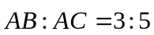.

3. [4 marks]

Determine the vector 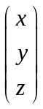 which has a magnitude of 6 units and makes an angle of 35º and 80º with the positive x and y axes respectively.

4. [8 marks]

A jet traveling at (–200i + 150j + 0.5k) km/hr passes through the point (50i – 20j + 3.8k) km at 2 pm one day. At the same time a light plane is at (–238i + 460j + 4.52k) km travelling at at (–80i – 50j + 0.2k) km/hr.
If the aircraft continue as above prove that the planes will collide and find the time and place of the collision.
- [4,3]
From an observation base, position (0,0,0) in Afghanistan, an Australian Captain observes an enemy Taliban military jet fighter, travelling at velocity (36i – 72 j + 8k) passing into a “no fly Zone”. At this instant she fires a missile at velocity (-130i +185 j + 66k) m/s, which after three seconds collides with the enemy jet and destroys in on impact.
  - At what position, relative to the observation base, did the military jet cross into the “no fly Zone”.

  - How close was the military jet to the observation base, when it was destroyed?

.

8. [2,3,3]

a.
Let the position vectors of points P and Q be
p = i + 4 j −k and q =-i +3 j − 4k

i. Find the magnitude of the vector PQ
ii Find the vector projection of p on q
iii. Find a vector parallel to q with the same magnitude as p
9. [2,2,2]

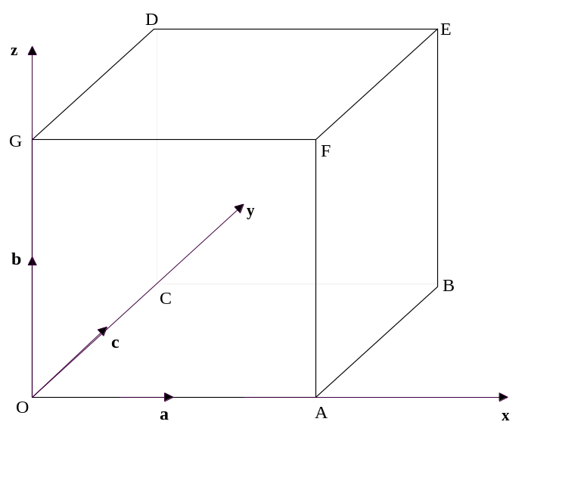

(a is the position vector of point A from O, etc.)
find
(a) a vector expression for a, b and c given |a|, |b| and |c| = 1.

(b) EG and EB.

(c) Prove EG is perpendicular to EB.

Matrices

12. [6 marks]

The Jetaway airline company owns three different types of aircraft : Jet1, Jet2 and Jet3. Each carries a number of first class, business class and economy class passengers. The number of seats of each class in each type of aircraft is given in the following table :

Aircraft type
Jet1 Jet2 Jet3
First class 10 10 20
Business class 20 30 40
Economy class 40 50 70

How many fully laden flights of each type of aircraft are needed to transport 150 first class, 340 business class and 600 economy class passengers ?

13. [7 marks]

A piece of metal is the shape of an equilateral triangle (shown below), is to be tested for heat transfer. It is known that the temperatures a, b and c (in degrees C) at the three interior points are the mean of the temperatures of the surrounding points.

For example the temperature a = (20 + 20 + b + c + 15 + 15)/6

It is also known that the edges of the metal are kept at constant temperatures of 10, 15 and 20 degrees.

20 15

a
20 15

b c
20 b 15

10 10 10

- Write down the equations for a, b and c as a system of linear equations.

[3]

- b. Determine the temperatures at the interior positions a, b and c.
Clearly outline your method.

[4]

- [11 marks]

A manufacturer of lawn fertiliser produces three different brands of fertiliser, YouBeaut, GrowGood and UpSprout, each comprising different quantities of urea, phosphate and potash. The quantity of each ingredient in kg (kilograms), in each 20 kg bag of fertiliser, is given in the following table.

Fertiliser Brand
You Beaut GrowGood UpSprout
Urea 5 6 5
Phosphate 10 8 12
Potash 5 6 3

Each of the following questions must be answered using matrices. The use of matrices must be clearly evident in your solutions.

- If the manufacturer had an order for 85 bags of YouBeaut, 110 bags of GrowGood and 135 bags of UpSprout, what quantity of each ingredient would be needed ?

[3]

14. b. The manufacturer had a stockpile of 9 930 kg of urea, 18 900 kg of phosphate and 8 370 kg of potash. How many bags of each type of fertiliser could be manufactured to completely use the stockpile ?

[5]

c. On the sale of the stockpile, the profit was $18 for each bag of YouBeaut and $15 for each bag of GrowGood. Given that the overall profit was $19.50 per bag, what was the profit on each bag of UpSprout ?

[3]
- [11 marks]

Traffic flows from the west to the east (left to right) and from the south to the north along four one way streets. In a given hour, 200 and 300 vehicles enter from the west and 250 and 350 vehicles exit toward the east. Also, 100 and 400 vehicles enter from the south and 200 exit from each street toward the north.

At each intersection, the number of vehicles entering the intersection must equal the number of vehicles leaving. Furthermore all cars entering from either west or south exit east or north within the hour.

The problem is to find the numbers of vehicles w, x, y and z travelling between the intersections.

- 200

300 y 350

z x

200 w 250

100 400

- State the system of linear equations in w, x, y and z for this problem.

[4]

b. Express this linear system in the matrix form AX = B

[2]

17. [12 marks]

Deltaepsilon, a manufacturer makes two types of products, Alpha and Beta, at two plants, X and Y. In the manufacture of these products, the following pollutants result : sulphur dioxide, carbon monoxide and particulate matter. At either plant, the daily pollutants resulting from the production of product Alpha are :

300 kg of sulphur dioxide
100 kg of carbon monoxide
200 kg of particulate matter

and of product Beta are : 400 kg of sulphur dioxide
500 kg of carbon monoxide
300 kg of particulate matter

a. Tabulate this information as a 2 by 3 matrix called P.

[1]

To satisfy federal regulations, these pollutants must be removed. Suppose the daily cost in dollars for removing each kg of pollutants at plant X is :

$5 per kg for sulphur dioxide
$3 per kg for carbon monoxide
$2 per kg for particulate matter

and at plant Y is : $8 per kg for sulphur dioxide
$4 per kg for carbon monoxide
$2 per kg for particulate matter

b. Represent this cost information as a 3 by 2 matrix called C.

[1]
17. c. Find the matrix A = PC .

[2]

d. Give the meaning of matrix A and explain what the element a₂₁ means.

[1]

e. Matrix B is defined such that B is the product of matrix A and 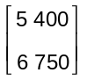.
Find B.

[2]

f. Give the meaning of the entries in matrix B.

[1]

17. g. Matrix T is the product of matrix B and 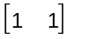. Find T.

[1]

h. Give the meaning of the entries in matrix T.

[1]

i. Identify a matrix product (using the matrices given), which could be used to calculate the daily costs of each plant.

[2]

